Exploratory Data Analysis

The dependent variable of interest percent_republican and the 7 independent explanatory variables have the following summary statistics:

average_age percent_republican_2012 percent_white

Min. :18.00 Min. : 5.978 Min. : 2.50

1st Qu.:37.10 1st Qu.:50.538 1st Qu.:67.65

Median :39.90 Median :60.791 Median :86.30

Mean :39.86 Mean :59.653 Mean :78.75

3rd Qu.:42.80 3rd Qu.:70.277 3rd Qu.:94.30

Max. :62.50 Max. :95.862 Max. :99.20

percent_degree percent_uninsured

Min. : 3.70 Min. : 3.10

1st Qu.:13.10 1st Qu.:14.00

Median :16.80 Median :17.70

Mean :19.01 Mean :17.99

3rd Qu.:22.60 3rd Qu.:21.50

Max. :71.00 Max. :46.00

percent_unemployed average_income percent_republican

Min. : 0.800 Min. : 0 Min. : 4.122

1st Qu.: 5.800 1st Qu.:22332 1st Qu.:54.960

Median : 7.500 Median :24825 Median :66.715

Mean : 7.706 Mean :25461 Mean :63.600

3rd Qu.: 9.300 3rd Qu.:27549 3rd Qu.:75.033

Max. :28.300 Max. :56674 Max. :95.273

Also of importance for an initial explanatory analysis is a list of the correlation coefficient between each independent explanatory variable and the dependent variable percent_republican, shown below.

#average_age 0.3325677

#percent_republican_2012 0.9347904

#percent_white 0.5365550

#percent_uninsured 0.1950089

#percent_degree -0.4936432

#percent_unemployed -0.2728920

#average_income -0.1996266

Let’s now take a closer look at our 8 varibales.

1. Percent_republican: This variable is measuring the Republican percentage of the vote in the 2016 presidential election. It appears to be roughly normally distributed with the median and mean relatively close in value(66.7% and 63.6%) respectively. The first quintile is 55.0% and the 3rd quintile is 75.0% with a min of 4.1% and a max of 95.3%.
2. Percent_republican 2012: This variable is the most strongly correlated with percent_republican with a correlation coefficient of 0.93, given that party affiliation usually doesn’t change over 4 years. Like percent_republican it is normally distributed, with the median and mean being very close in value(60.8% and 59.7%) respectively. Below is a plot showing the strong linear correlation between percent_republican 2012 and percent_republican.

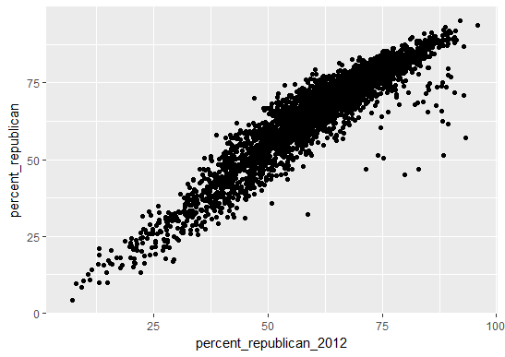

1. Percent_white: After percent_republican_2012, this is the 2nd most highly correlated variable with percent_republican with a correlation coefficient of 0.54, as seen in the scatter plot below. This variable appears to be skewed, with the median being greater than the mean (86.3% vs 78.8% respectively). In the scatter plot, it can be seen that there is a very high concentration of points on the right side with percent_white between% 90 to 100% and percent_republican between 50 and 75%.

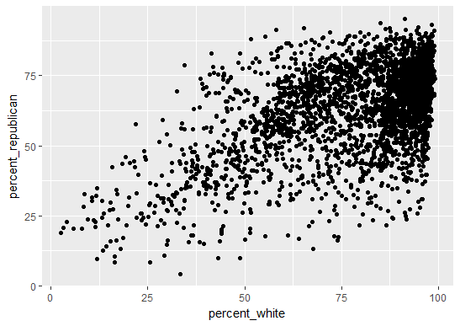

1. Percent_degree: This variable has a moderately strong negative correlation with percent_republican on -0.49. The scatter plot below shows this correlation. Most of the points lie in the upper left corner with percent_degree between 10 to 20% and percent_republican between 55% and 75%. Most of the counties where percent_degree is 40% or more have a Republican share of the vote that is less than 50%. It appears to be approximately normally distributed, perhaps with a slight skew, with a median of 16.8% and mean of 19.0%.

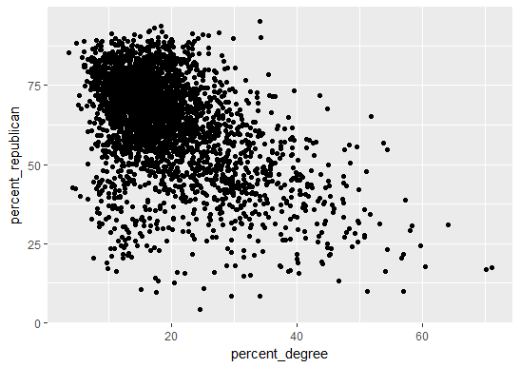

1. Average_age: This variable is normally distributed, with median and mean being virtually the same (39.90 years and 39.86 years respectively). This variable has a small to moderate-sized positive correlation with percent_republican; the correation coefficient is 0.33. A plot is shown below.

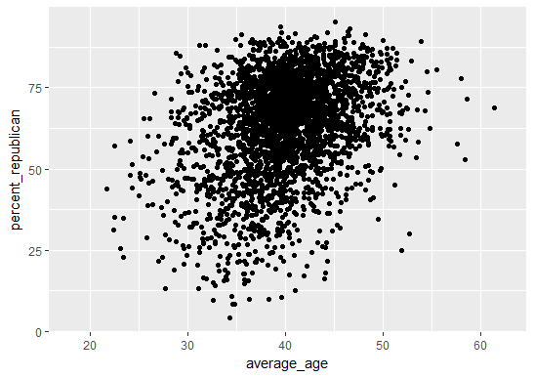

1. Percent_unemployed: This variable is normally distributed, with median and mean being virtually the same (7.5% and 7.7% respectively). This variable has a small to moderate-sized negatve correlation with percent_republican; the correation coefficient is -0.27. A plot is shown below.

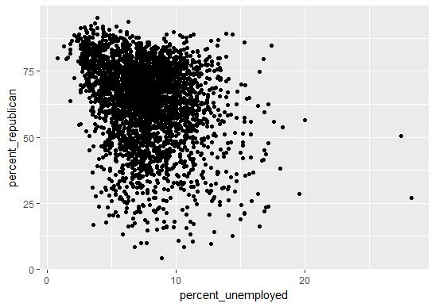

1. Percent_uninsured: This variable is normally distributed, with median and mean being virtually the same (17.70% and 17.99 respectively). This variable has a small positive correlation with percent_republican; the correlation coefficient is 0.195. This would mean that the R-squared value is less than 0.04; percent_unemployed explains less than 4% of the variability in percent_republican, which does not indicate a good fit for a model from an initial standpoint. A plot is shown below. An inspection of the plot shows that it is hard to discern a clear positive linear correlation.

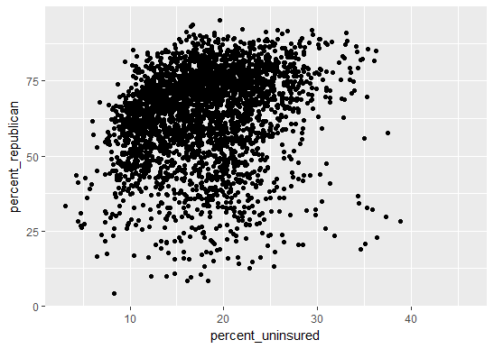

1. Average_income: This variable is normally distributed, with median and mean both being around $25,000. This variable has a small negative correlation with percent_republican; the correlation coefficient is approximately -0.20. This would mean that the R-squared value is labout 0.04; the individual average annual income explains less than 4% of the variability in the 2016 share of the Republican vote, which does not indicate a good fit for a model from an initial standpoint. A plot is shown below. An inspection of the plot shows that it is hard to discern a clear negative linear correlation.

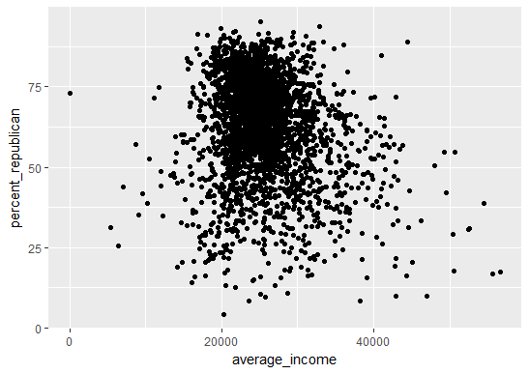

Based on this initial exploratory analysis, it appears that percent_republican_2012, percent_white, and percent_degree will be good explanatory variables for our model. Machine testing will need to be done to determine if the other 4 independent variables will also be good explanatory variables. Based on this initial assessment, there is reason to suspect that percent_unemployed and average_income may not be good variables for our linear regression model.